**Thomas Collins**

**ME 705 Thermal Systems Analysis and Design**

**Due: 10/9/2018**

Pg. 1

**Thermal Management of a Drone Pod System**

Abstract

The department of defense has contracted us to complete an analysis of a thermal management system for a drone pod system. This task shall be completed in three sections. First is two analysis consisting of temperature vs entropy and pressure vs enthalpy. The second section is coefficient of performance (COP) vs temperature (T) for three selected refrigerants. Investigation will also include the thermal, environmental safety, and cost considerations as to determine the best refrigerant for the drone pod. The last analysis will be focused towards the COP again with factoring in the difference from the outside temperature to the working fluid temperature and its respective actual performance on the field.

Analysis

To understand what refrigerant to select we must first understand the relationships between critical thermodynamic properties. These properties are as follows: temperature, pressure, entropy, enthalpy, and volume. The first relationship to analyze is Temperature (T) vs Entropy (S). This was done by simulating a refrigeration cycle between two different outside temperature points. The selection of two outside temperature points was to observe how the cycle preformed under different situations.

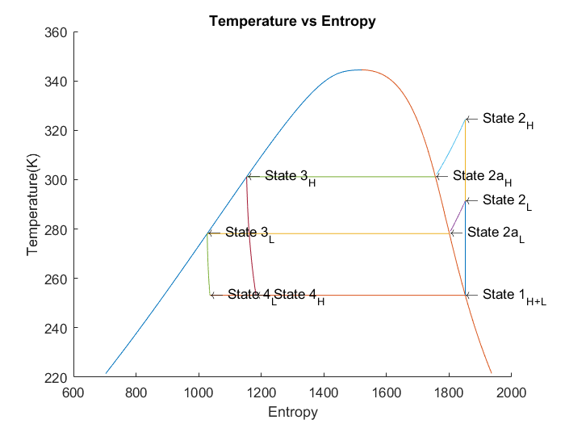

*Figure #1. Temperature vs Entropy*

As you can see in Figure #1 there are two distinct refrigeration cycles. These are notated by their (H) for high or

(L) for low environmental temperature cycles. For this graph specifically, the (L) cycle was taken with an outside temperature of 5oC or 278.15K. For the (H) cycle the environmental temperature used was 29oC or 302.15K. With the increase in environmental temperature the Entropy difference between State #3 and State #1 increased. This is reinforced in the Low temperature cycle where the difference between Entropy in State #3 and State #1 is less than that of the high. Physically for the refrideration system this means that more work must be down to bring down the environmental temp to the working fluid temp.

The second thermal property analysis is that of Pressure vs Enthalpy. This was as well done with a High (H) and Low (L) environmental temperature difference.

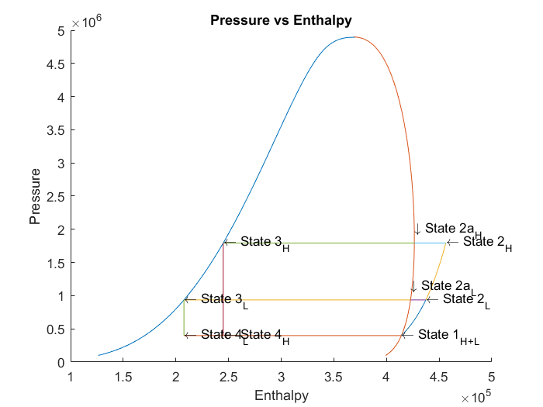

*Figure #2. Pressure vs Enthalpy*

Figure #2 shows us two more properties and their respective cycles. Physical relationships we can determine here include the increasing pressure due to the environmental termperature will related to an increasing amount of work done by the cycle in order to bring that pressure down to that of the working fluid.

The last thermal property analysis is that of Pressure vs Volume. This follows the same pattern as the past two by including a low and high environmental temperature.

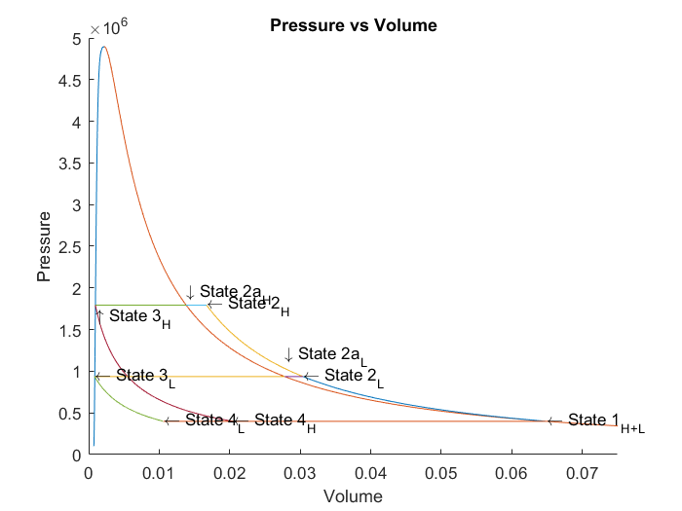

*Figure #3. Pressure vs Volume*

Figure #3 gives us our final thermodynamic property relationship, Pressure and Volume. With this we can visually relate the past three graphs, which State changes are isobaric, isothermal, isotropic, and isenthalpic. The refridgeration cycle consists of two isobaric, one isotropic, and one isenthalpic process.

Next, we shall be doing a quantitiative study of three different refrigerant’s COP and Flow Rate. For this study I have chosen the refrigerant R410a, R32, and R40. These were chosen based on their thermal properties, environmental safety, and cost.

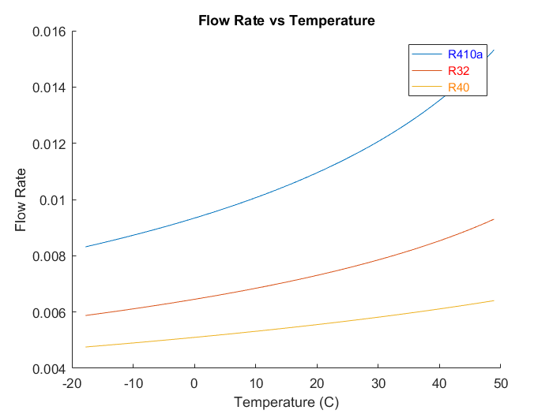

*Figure #4. Flow Rate vs Temperature*

Analysis the data presented in figure #4 leads us to tell that the Mass Flow Rates for R410a, R32, and R40 decrease respectively. This is due to each refrigerants heat capacity and the amount needed to cool or heat up the system.

Pg. 2

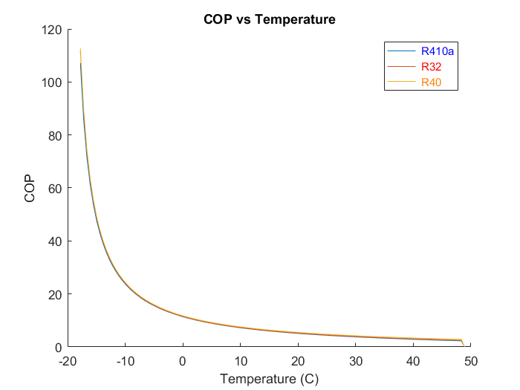

*Figure #5. COP vs Temperature*

With the chosen refrigerants, their respective COP’s are nearly identical per temperature.

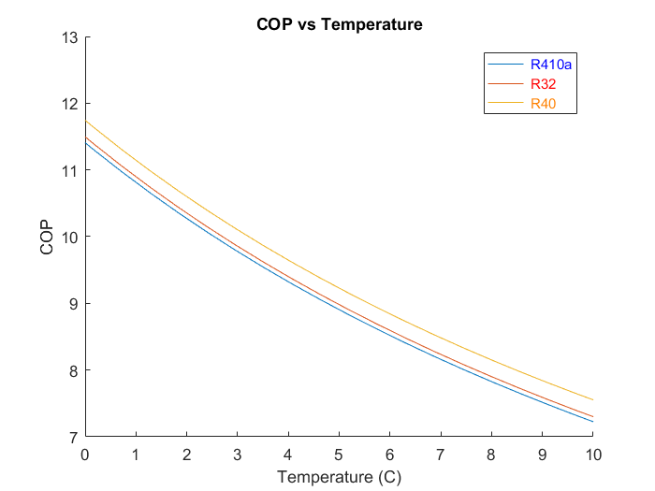

*Figure #6. COP vs Temperature Expanded View*

In an effort to show the differnce between the COP’s per Temperature I have limited the x-axis to 0oC and 10oC and the y-axis to 7 through 13. With this we can tell that the refrigerantwith the highest COP per given Temperature is R40.

Further analysis of R40 shows that although it is a very effective refrigerant [2], it is no longer used today. [1] The refidgerant is colorless, extremely flammible, with a mildly sweet smell.[1] Apart from that its toxicity to humans and other organic life make it so that it is to dangerous to be used in consumer products, and thus is not a suitable choice for our Drone Pod System.

The next refiderant is R32. R32 is a relativly new refidgerant with more promising prospects. It has a low heat

capacity and thus conveys heat in a efficent way.[3] The refrigerant also has a Global Warming Potential that is 30% less than that of R410a, thus making it a clear choice environmentally. [3] With these pros we must look on the contrary, some cons to R32 are that it is extremely difficult to handle which has lead to only one company being able to sucessfully manage and incorperate it into refriderants, Daikin.[3] This fact puts R32 into the cost inefficient category, making it expensive to purchase and maintain.

Lastly, the analysis of the properties of R410a. This refrigerant must included in our testing due to its presence in the consumer market as one of the most widely used refrigerant working fluids.[5] One of the main highlights of R410a is its ease of transportation due to its porterties in both a saturated liquid and vaport state.[6] These properties amount to a reduced viscous losses in the compressor, along with improved heat transfer characteristics in both the evaporator and condensor.[5] These properties of R410a result in it being the best refidgerant to use for our Drone Pod System.

The COP vs Temperature simulation was taken with a temperature range between 0oF and 120oF or -18oC to 49oC. This represents the temperature range the drone will experience while flying and on the ground throughout multiple climates.

The effects of the temperature difference between the cycle and the environment on the COP have been in part discussed before. In general, you can assume that the COP will drop when the temperature difference is large and rise when the difference is small. In figure #4 you can observe this phenominon because each refrigerant or working fluid had a working temperature of -20oC. Thus, when the outside temperature approached -20oC the COP increased almost exponentially. On the contrary, when the environmental temperature increased the COP apporached zero.

Conclusion

In conclusion, the best suited refrigerant for our Drone Pod System is R410a. This decision was reached based on the analysis of the refrigerants COP, as well as its pros and cons with respect to thermal properties, environmental safety, and cost. Although R410a is not the best in each respective category it still proves to be the best working fluid overall.

References

1. “Chloromethane.” Wikipedia, Wikimedia Foundation, 23 Aug. 2018, en.wikipedia.org/wiki/Chloromethane.
2. “R40.” R40 - CoolProp 6.1.0 Documentation, www.coolprop.org/fluid_properties/fluids/R40.html#fluid-r40.
3. “R-32Next-Generation Refrigerant.” VRV (Multi-Split Type Air Conditioners) Air Conditioning and

Pg. 3

1. Refrigeration. | Daikin Global, [www.daikin.com/about/why_daikin/benefits/r-32/](http://www.daikin.com/about/why_daikin/benefits/r-32/).
2. “R410A.” R40 - CoolProp 6.1.0 Documentation, [www.coolprop.org/fluid_properties/fluids/R410A.html#fluid-r410a](http://www.coolprop.org/fluid_properties/fluids/R410A.html#fluid-r410a)
3. “R-410A.” Wikipedia, Wikimedia Foundation, 18 Sept. 2018, en.wikipedia.org/wiki/R-410A.
4. B. D. Bivens, et al. “R-410A – Application Experience.” R-410A – Why Is It Such an Interesting

Refrigerant Fluid, www.eurocooling.com/public_html/articler410a.htm.

1. “Author Templates.” ASME.org, [www.asme.org/shop/proceedings/conference-publications/author-templates](http://www.asme.org/shop/proceedings/conference-publications/author-templates).

Project #1 Code  
clear all  
close all  
addpath('../')  
  
%Variables  
wf='R410a';  
  
%State #1  
T1=-20+273.15; %Patm in Pa  
x1=1;  
P1=CoolProp.PropsSI('P','T',T1,'Q',x1,wf);  
H1=CoolProp.PropsSI('H','T',T1,'Q',x1,wf);  
S1=CoolProp.PropsSI('S','T',T1,'Q',x1,wf);  
V1=1./CoolProp.PropsSI('D','T',T1,'Q',x1,wf);  
  
%State #3 [Temperature for Summer and Winter]  
T3_Summer=28+273.15;  
T3_Winter= 5 + 273.15;  
x3=0;  
P3_Summer=CoolProp.PropsSI('P','T',T3_Summer,'Q',x3,wf);  
H3_Summer=CoolProp.PropsSI('H','T',T3_Summer,'Q',x3,wf);  
S3_Summer=CoolProp.PropsSI('S','T',T3_Summer,'Q',x3,wf);  
V3_Summer=1./CoolProp.PropsSI('D','T',T3_Summer,'Q',x3,wf);  
P3_Winter=CoolProp.PropsSI('P','T',T3_Winter,'Q',x3,wf);  
H3_Winter=CoolProp.PropsSI('H','T',T3_Winter,'Q',x3,wf);  
S3_Winter=CoolProp.PropsSI('S','T',T3_Winter,'Q',x3,wf);  
V3_Winter=1./CoolProp.PropsSI('D','T',T3_Winter,'Q',x3,wf);  
  
  
%State #4  
T4_Summer=T1;  
T4_Winter=T1;  
H4_Summer=H3_Summer;  
H4_Winter=H3_Winter;  
P4_Summer=P1;  
P4_Winter=P1;  
S4_Summer=CoolProp.PropsSI('S','P',P4_Summer,'H',H4_Summer,wf);  
V4_Summer=1./CoolProp.PropsSI('D','P',P4_Summer,'H',H4_Summer,wf);  
S4_Winter=CoolProp.PropsSI('S','P',P4_Winter,'H',H4_Winter,wf);  
V4_Winter=1./CoolProp.PropsSI('D','P',P4_Winter,'H',H4_Winter,wf);  
  
  
%State #2a  
P2a_Summer=P3_Summer;  
P2a_Winter=P3_Winter;  
x2a= 1;  
T2a_Summer=T3_Summer;  
T2a_Winter=T3_Winter;  
H2a_Summer=CoolProp.PropsSI('H','P',P2a_Summer,'Q',x2a,wf);  
S2a_Summer=CoolProp.PropsSI('S','P',P2a_Summer,'Q',x2a,wf);  
V2a_Summer=1./CoolProp.PropsSI('D','P',P2a_Summer,'Q',x2a,wf);  
H2a_Winter=CoolProp.PropsSI('H','P',P2a_Winter,'Q',x2a,wf);  
S2a_Winter=CoolProp.PropsSI('S','P',P2a_Winter,'Q',x2a,wf);  
V2a_Winter=1./CoolProp.PropsSI('D','P',P2a_Winter,'Q',x2a,wf);  
  
%State #2  
S2_Summer=S1;  
S2_Winter=S1;  
P2_Summer=P2a_Summer;  
P2_Winter=P2a_Winter;  
T2_Summer=CoolProp.PropsSI('T','P',P2_Summer,'S',S2_Summer,wf);  
H2_Summer=CoolProp.PropsSI('H','P',P2_Summer,'S',S2_Summer,wf);  
V2_Summer=1./CoolProp.PropsSI('D','P',P2_Summer,'S',S2_Summer,wf);  
T2_Winter=CoolProp.PropsSI('T','P',P2_Winter,'S',S2_Winter,wf);  
H2_Winter=CoolProp.PropsSI('H','P',P2_Winter,'S',S2_Winter,wf);  
V2_Winter=1./CoolProp.PropsSI('D','P',P2_Winter,'S',S2_Winter,wf);  
  
% Vapor Dome Matrix  
  
% T vs S  
Pressures =linspace(100000,4900000,1000);  
Ta=zeros(length(Pressures),1);  
Tb=zeros(length(Pressures),1);  
Sa=zeros(length(Pressures),1);  
Sb=zeros(length(Pressures),1);  
for ii=1:length(Pressures)  
 Ta(ii)=CoolProp.PropsSI('T','P',Pressures(ii),'Q',0,wf);  
 Tb(ii)=CoolProp.PropsSI('T','P',Pressures(ii),'Q',1,wf);  
 Sa(ii)=CoolProp.PropsSI('S','P',Pressures(ii),'Q',0,wf);  
 Sb(ii)=CoolProp.PropsSI('S','P',Pressures(ii),'Q',1,wf);  
end  
  
%P vs H  
  
  
Ha=zeros(length(Pressures),1);  
Hb=zeros(length(Pressures),1);  
Pa=zeros(length(Pressures),1);  
Pb=zeros(length(Pressures),1);  
for ii=1:length(Pressures)  
 Ha(ii)=CoolProp.PropsSI('H','P',Pressures(ii),'Q',0,wf);  
 Hb(ii)=CoolProp.PropsSI('H','P',Pressures(ii),'Q',1,wf);  
 Pa(ii)=CoolProp.PropsSI('P','P',Pressures(ii),'Q',0,wf);  
 Pb(ii)=CoolProp.PropsSI('P','P',Pressures(ii),'Q',1,wf);  
end  
  
%P vs V  
  
Va=zeros(length(Pressures),1);  
Vb=zeros(length(Pressures),1);  
Pa=zeros(length(Pressures),1);  
Pb=zeros(length(Pressures),1);  
for ii=1:length(Pressures)  
 Va(ii)=1./CoolProp.PropsSI('D','P',Pressures(ii),'Q',0,wf);  
 Vb(ii)=1./CoolProp.PropsSI('D','P',Pressures(ii),'Q',1,wf);  
 Pa(ii)=CoolProp.PropsSI('P','P',Pressures(ii),'Q',0,wf);  
 Pb(ii)=CoolProp.PropsSI('P','P',Pressures(ii),'Q',1,wf);  
end  
  
% For loops for Processes  
  
% Process Calculations : Loops  
  
%State 2 to 2a  
  
Pressure_22a_Summer = [P2_Summer,P2_Summer];  
Pressure_22a_Winter = [P2_Winter,P2_Winter];  
  
H_22a_Summer = [H2_Summer,H2a_Summer]; %New  
H_22a_Winter = [H2_Winter,H2a_Winter]; %New  
  
Temperature_22a_Summer = linspace(T2_Summer,T2a_Summer+1,1000);  
Temperature_22a_Winter = linspace(T2_Winter,T2a_Winter+1,1000);  
  
S_22a_Summer = zeros(length(Temperature_22a_Summer),1);  
S_22a_Winter = zeros(length(Temperature_22a_Winter),1);  
  
V_22a_Summer = [V2_Summer,V2a_Summer]; %New  
V_22a_Winter = [V2_Winter,V2a_Winter]; %New  
  
  
for i = 1:length(Temperature_22a_Summer)  
 S_22a_Summer(i) = CoolProp.PropsSI('S','P',Pressure_22a_Summer(1),'T',Temperature_22a_Summer(i),wf);  
 S_22a_Winter(i) = CoolProp.PropsSI('S','P',Pressure_22a_Winter(1),'T',Temperature_22a_Winter(i),wf);  
end  
  
% State 3 to 4  
  
H_34_Summer = linspace(H3_Summer,H4_Summer,1000);  
H_34_Winter = linspace(H3_Winter,H4_Winter,1000);  
  
S_34_Summer = linspace(S3_Summer,S4_Summer,1000);  
S_34_Winter = linspace(S3_Winter,S4_Winter,1000);  
  
Temperature_34_Summer = zeros(length(S_34_Summer),1);  
Temperature_34_Winter = zeros(length(S_34_Summer),1);  
  
Pressure_34_Summer = [P3_Summer,P4_Summer]; %New  
Pressure_34_Winter = [P3_Winter,P4_Winter]; %New  
  
V_34_Summer = [V3_Summer,V4_Summer]; %New  
V_34_Winter = [V3_Winter,V4_Winter]; %New  
  
  
for i = 1:length(Temperature_34_Summer)  
 Temperature_34_Summer(i) = CoolProp.PropsSI('T','H',H_34_Summer(1),'S',S_34_Summer(i),wf);  
 Temperature_34_Winter(i) = CoolProp.PropsSI('T','H',H_34_Winter(1),'S',S_34_Winter(i),wf);  
 V_34_Summer(i) = 1./CoolProp.PropsSI('D','H',H_34_Summer(1),'S',S_34_Summer(i),wf); %New  
 V_34_Winter(i) = 1./CoolProp.PropsSI('D','H',H_34_Winter(1),'S',S_34_Winter(i),wf); %New  
 S_34_Summer(i) = CoolProp.PropsSI('S','H',H_34_Summer(1),'S',S_34_Summer(i),wf); %New  
 S_34_Winter(i) = CoolProp.PropsSI('S','H',H_34_Winter(1),'S',S_34_Winter(i),wf); %New  
 Pressure_34_Summer(i) = CoolProp.PropsSI('P','H',H_34_Summer(1),'S',S_34_Summer(i),wf); %New  
 Pressure_34_Winter(i) = CoolProp.PropsSI('P','H',H_34_Winter(1),'S',S_34_Winter(i),wf); %New  
end  
  
  
% State 1 to 2  
T_12_Summer = linspace(T1,T2_Summer,1000); %New  
T_12_Winter = linspace(T1,T2_Winter,1000); %New  
S_12_Summer = linspace(S1,S2_Summer,1000); %New  
S_12_Winter = linspace(S1,S2_Winter,1000); %New  
P_12_Summer = zeros(length(Temperature_22a_Summer),1); %New  
P_12_Winter = zeros(length(Temperature_22a_Winter),1); %New  
V_12_Summer = zeros(length(Temperature_22a_Summer),1); %New  
V_12_Winter = zeros(length(Temperature_22a_Winter),1); %New  
H_12_Summer = zeros(length(Temperature_22a_Summer),1); %New  
H_12_Winter = zeros(length(Temperature_22a_Winter),1); %New  
  
for i = 1:length(Temperature_22a_Summer)  
 H_12_Summer(i) = CoolProp.PropsSI('H','S',S1,'T',T_12_Summer(i),wf); %New  
 H_12_Winter(i) = CoolProp.PropsSI('H','S',S1,'T',T_12_Winter(i),wf); %New  
 P_12_Summer(i) = CoolProp.PropsSI('P','S',S1,'T',T_12_Summer(i),wf); %New  
 P_12_Winter(i) = CoolProp.PropsSI('P','S',S1,'T',T_12_Winter(i),wf); %New  
 V_12_Summer(i) = 1./CoolProp.PropsSI('D','S',S1,'T',T_12_Summer(i),wf); %New  
 V_12_Winter(i) = 1./CoolProp.PropsSI('D','S',S1,'T',T_12_Winter(i),wf); %New  
end  
  
% State 4 to 1  
  
  
T_41_Summer = [T4_Summer,T1];  
T_41_Winter = [T4_Winter,T1];  
S_41_Summer = [S4_Summer,S1];  
S_41_Winter = [S4_Winter,S1];  
P_41_Summer = [P4_Summer,P1]; %New  
P_41_Winter = [P4_Winter,P1]; %New  
H_41_Summer = [H4_Summer,H1]; %New  
H_41_Winter = [H4_Winter,H1]; %New  
V_41_Summer = [V4_Summer,V1]; %New  
V_41_Winter = [V4_Winter,V1]; %New  
  
  
% State 2a to 3  
  
T_2a3_Summer = [T2a_Summer,T3_Summer];  
T_2a3_Winter = [T2a_Winter,T3_Winter];  
S_2a3_Summer = [S2a_Summer,S3_Summer];  
S_2a3_Winter = [S2a_Winter,S3_Winter];  
P_2a3_Summer = [P2a_Summer,P3_Summer]; %New  
P_2a3_Winter = [P2a_Winter,P3_Winter]; %New  
H_2a3_Summer = [H2a_Summer,H3_Summer]; %New  
H_2a3_Winter = [H2a_Winter,H3_Winter]; %New  
V_2a3_Summer = [V2a_Summer,V3_Summer]; %New  
V_2a3_Winter = [V2a_Winter,V3_Winter]; %New  
  
% Graph for T-S  
figure  
hold on  
title ('Temperature vs Entropy')  
xlabel ('Entropy')  
ylabel ('Temperature(K)')  
 %Vap Dome  
plot(Sa,Ta,Sb,Tb)  
 %T-S  
plot(S_12_Summer,T_12_Summer,S_41_Summer,T_41_Summer,S_2a3_Summer,T_2a3_Summer)  
plot( S_22a_Summer,Temperature_22a_Summer,S_34_Summer,Temperature_34_Summer)  
plot(S_12_Winter,T_12_Winter,S_41_Winter,T_41_Winter,S_2a3_Winter,T_2a3_Winter) %New  
plot( S_22a_Winter,Temperature_22a_Winter,S_34_Winter,Temperature_34_Winter) %New  
 text(S1,T1,'\leftarrow State 1_H_+_L')  
 text(S2_Summer,T2_Summer,'\leftarrow State 2_H')  
 text(S2a_Summer,T2a_Summer,'\leftarrow State 2a_H')  
 text(S3_Summer,T3_Summer,'\leftarrow State 3_H')  
 text(S4_Summer,T4_Summer,'\leftarrow State 4_H')  
 text(S2_Winter,T2_Winter,'\leftarrow State 2_L')  
 text(S2a_Winter,T2a_Winter,'\leftarrow State 2a_L')  
 text(S3_Winter,T3_Winter,'\leftarrow State 3_L')  
 text(S4_Winter,T4_Winter,'\leftarrow State 4_L')  
  
%Graph for P-h  
figure  
hold on  
title ('Pressure vs Enthalpy')  
xlabel ('Enthalpy')  
ylabel ('Pressure')  
 %Vap Dome  
plot (Ha,Pa,Hb,Pb)  
 %P-H  
plot(H_12_Summer,P_12_Summer,H_41_Summer,P_41_Summer,H_2a3_Summer,P_2a3_Summer) %New  
plot( H_22a_Summer,Pressure_22a_Summer,H_34_Summer,Pressure_34_Summer) %New  
plot(H_12_Winter,P_12_Winter,H_41_Winter,P_41_Winter,H_2a3_Winter,P_2a3_Winter) %New  
plot( H_22a_Winter,Pressure_22a_Winter,H_34_Winter,Pressure_34_Winter) %New  
 text (H1,P1,'\leftarrow State 1_H_+_L')  
 text (H2_Summer,P2_Summer,'\leftarrow State 2_H')  
 text (H2a_Summer,P2a_Summer+(0.2*10^6),'\downarrow State 2a_H')  
 text (H3_Summer,P3_Summer,'\leftarrow State 3_H')  
 text (H4_Summer,P4_Summer,'\leftarrow State 4_H')  
 text (H2_Winter,P2_Winter,'\leftarrow State 2_L')  
 text (H2a_Winter,P2a_Winter+(0.2*10^6),'\downarrow State 2a_L')  
 text (H3_Winter,P3_Winter,'\leftarrow State 3_L')  
 text (H4_Winter,P4_Winter,'\leftarrow State 4_L')  
  
  
%Graph for P-V  
figure  
hold on  
title ('Pressure vs Volume')  
xlabel ('Volume')  
ylabel ('Pressure')  
 %Vap Dome  
plot (Va,Pa,Vb,Pb)  
xlim ([0,0.075])  
ylim ([0,5*10^6])  
 %P-V  
plot(V_12_Summer,P_12_Summer,V_41_Summer,P_41_Summer,V_2a3_Summer,P_2a3_Summer) %New  
plot( V_22a_Summer,Pressure_22a_Summer,V_34_Summer,Pressure_34_Summer) %New  
plot(V_12_Winter,P_12_Winter,V_41_Winter,P_41_Winter,V_2a3_Winter,P_2a3_Winter) %New  
plot( V_22a_Winter,Pressure_22a_Winter,V_34_Winter,Pressure_34_Winter) %New  
 text(V1,P1,'\leftarrow State 1_H_+_L')  
 text(V2_Summer,P2_Summer,'\leftarrow State 2_H')  
 text(V2a_Summer,P2a_Summer+(0.15*10^6),'\downarrow State 2a_H')  
 text(V3_Summer,P3_Summer+(-0.15*10^6),'\uparrow State 3_H')  
 text(V4_Summer,P4_Summer,'\leftarrow State 4_H')  
 text(V2_Winter,P2_Winter,'\leftarrow State 2_L')  
 text(V2a_Winter,P2a_Winter+(0.25*10^6),'\downarrow State 2a_L')  
 text(V3_Winter,P3_Winter,'\leftarrow State 3_L')  
 text(V4_Winter,P4_Winter,'\leftarrow State 4_L')  
  
% Calculated Values  
 %COP  
wc_Summer = (H1-H2_Summer)/1000;  
ql_Summer = (H4_Summer-H1)/1000;  
fr_Summer = 5/((H4_Summer-H1)/1000);  
COP_Summer = ql_Summer/wc_Summer;  
wc_Winter = (H1-H2_Winter)/1000;  
ql_Winter = (H4_Winter-H1)/1000;  
fr_Winter = 5/((H4_Winter-H1)/1000);  
COP_Winter = ql_Winter/wc_Winter;  
  
COP =[COP_Summer,COP_Winter];  
  
%COP Graph  
Tdelta=[linspace(255.372,322.039,120);linspace(255.372,322.039,120);linspace(255.372,322.039,120)]';  
COPdelta=zeros(length(Tdelta),3);  
H1delta=zeros(length(Tdelta),3);  
H3delta=zeros(length(Tdelta),3);  
H4delta=zeros(length(Tdelta),3);  
H2delta=zeros(length(Tdelta),3);  
FlowRatedelta = zeros(length(Tdelta),3);  
  
for iii=1:length(Tdelta)  
 for j=1:3  
 if j==1  
 wf='R410a';  
 end  
 if j==2  
 wf='R32';  
 end  
 if j==3  
 wf='R40';  
 end  
  
 %State 1  
 x1=1;  
 T1=-20+273.15;  
H1delta(iii,j)=CoolProp.PropsSI('H','T',T1,'Q',x1,wf);  
 %State 3  
 x3=0;  
H3delta(iii,j)=CoolProp.PropsSI('H','T',Tdelta(iii,j),'Q',x3,wf);  
 %State 4  
H4delta(iii,j)=H3delta(iii,j);  
 %State 2  
 S1=CoolProp.PropsSI('S','T',T1,'Q',x1,wf);  
 S2=S1;  
 P3=CoolProp.PropsSI('P','T',Tdelta(iii,j),'Q',x3,wf);  
 P2=P3;  
H2delta(iii,j)=CoolProp.PropsSI('H','P',P2,'S',S2,wf);  
 %COP Calc  
 if Tdelta(iii,j) == 322.039  
 Power= 0.5;  
 else  
 Power=2.0;  
FlowRatedelta(iii,j)= Power/((H4delta(iii,j)-H1delta(iii,j))/1000);  
COPdelta(iii,j)=abs(((H4delta(iii,j)-H1delta(iii,j))/1000)/((H1delta(iii,j)-H2delta(iii,j))/1000));  
 end  
 end  
end  
figure  
hold on  
title ('COP vs Temperature')  
xlabel ('Temperature (C)')  
ylabel ('COP')  
xlim ([0,10])  
ylim ([7,13])  
plot (Tdelta-273.15,COPdelta)  
legend ('\color{blue} R410a','\color{red} R32','\color{orange} R40')  
  
figure  
hold on  
title ('Flow Rate vs Temperature')  
xlabel ('Temperature (C)')  
ylabel ('Flow Rate')  
plot (Tdelta-273.15, abs(FlowRatedelta))  
legend ('\color{blue} R410a','\color{red} R32','\color{orange} R40')